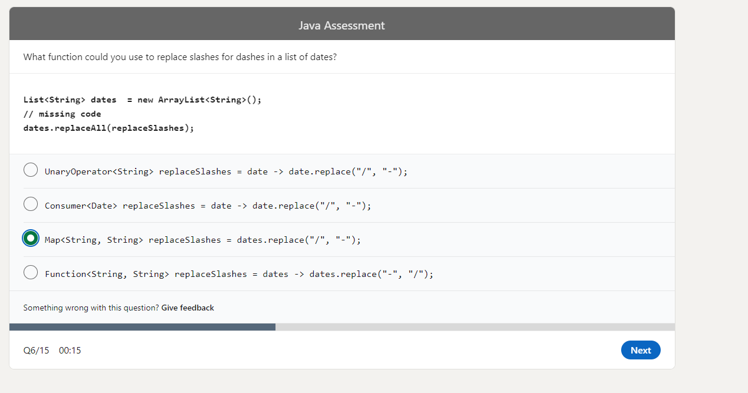

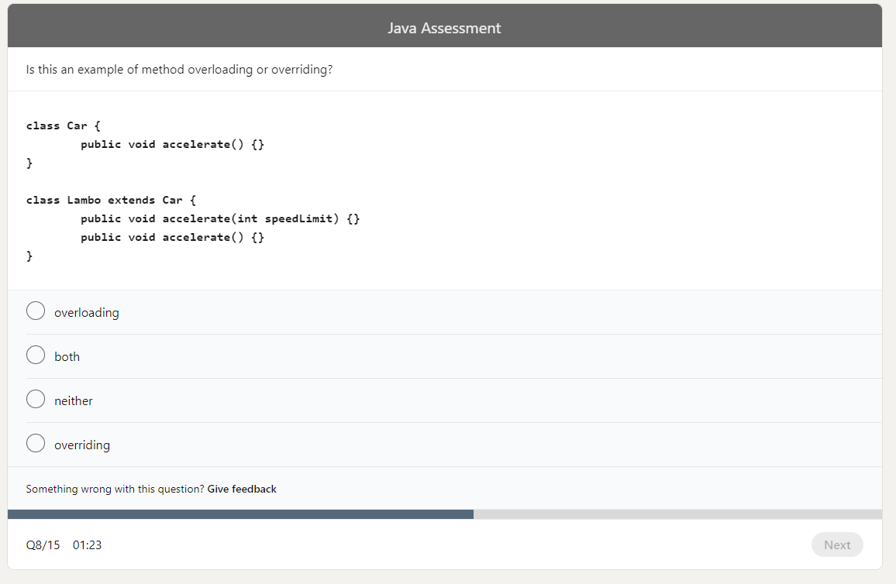

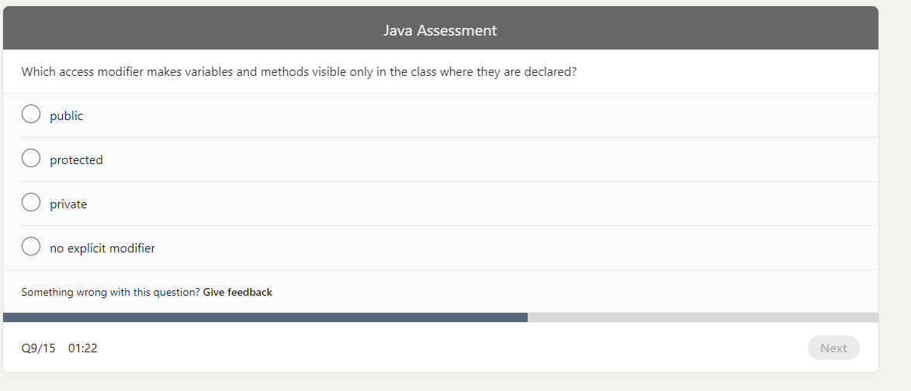

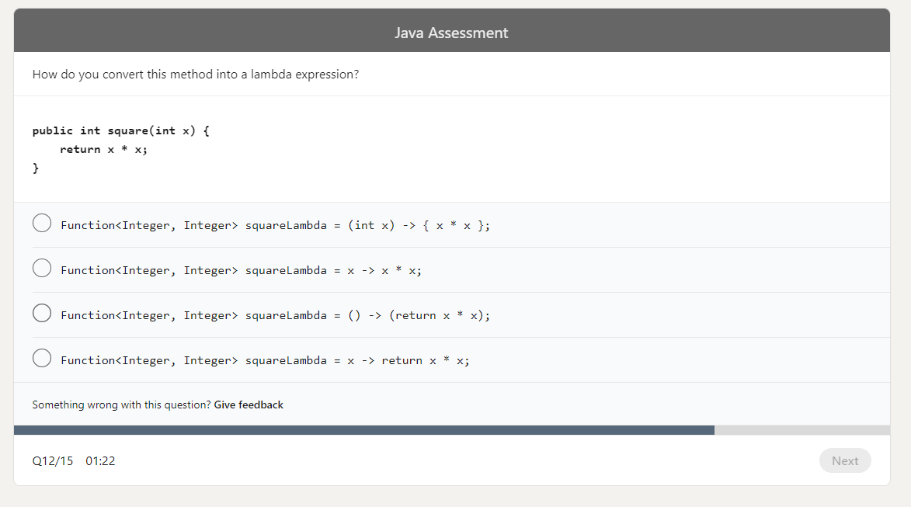

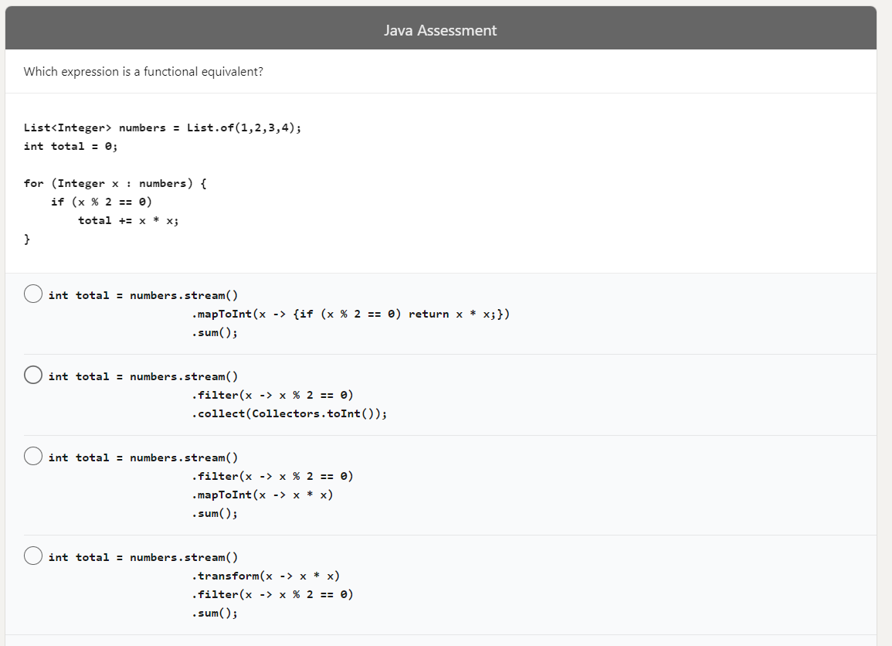

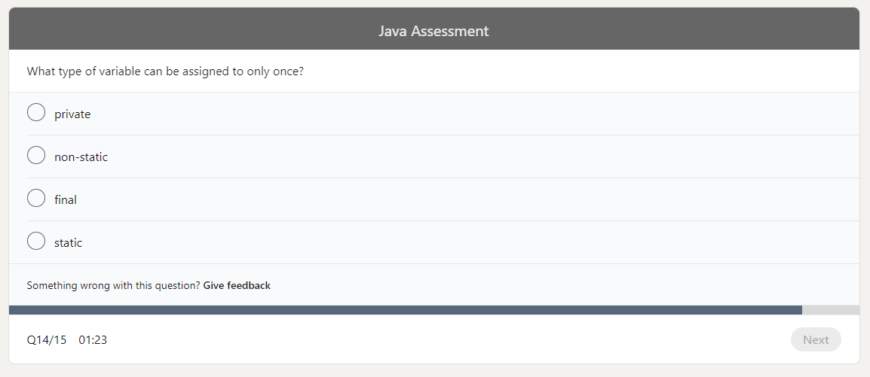

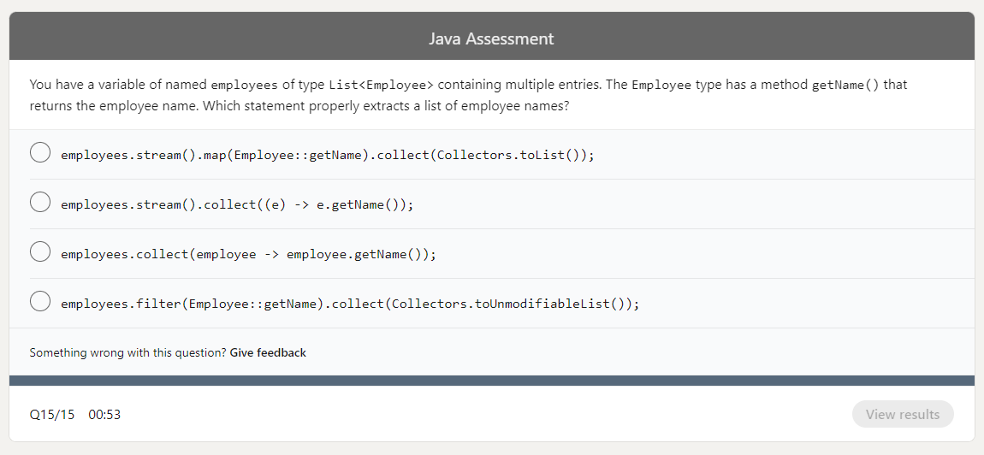

<https://www.linkedin.com/learning/search?keywords=Java>

<https://www.linkedin.com/feed/update/urn:li:lyndaCourse:2825378/>

<https://www.linkedin.com/feed/update/urn:li:lyndaCourse:375490/>

<https://www.linkedin.com/feed/update/urn:li:lyndaCourse:2453107/>

<https://www.linkedin.com/feed/update/urn:li:lyndaCourse:808674/>

<https://stackoverflow.com/questions/2857376/difference-between-java-se-ee-me>

<https://hackr.io/blog/java-certification-courses>